**Daily Scrum or Standup Meeting**

Team name: ________Group 2_________________

Scrum Master: ______Emily_________________

Date:__________11/7_____________________

| **Team Member** | **What did you do since the last scrum?** | **What do you plan to do before the next scrum?** | **What obstacles do you have?** |
| --- | --- | --- | --- |
| Emily | Took the weekend off | Update search results UI + set up view customer orders page | Time |
| Maris | Refactored relation between menu items and inventory items | build shopping cart page | little invisible bugs |
| Karl | Deathly sick | Fight this cold I’m sorry | Throwing up |
|  |  |  |  |
|  |  |  |  |

# Burndown

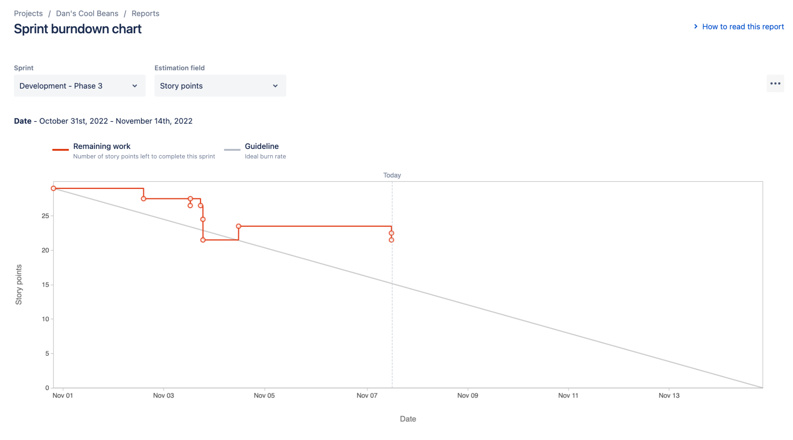

# Screenshot of you project board

